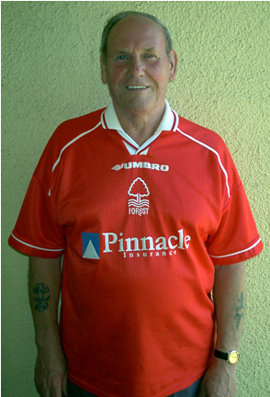

Branch Member Reg Brown. The Sec’s Dad!

The answers to the Richard’s Tricky Ten in Issue Eleven of the Newsletter are:

1. 1973-1974
2. 1990-1991
3. 1994-1995
4. 1992-1993
5. 1990-1991
6. 1988-1989
7. 1984-1985
8. 1980-1981
9. 1978-1979
10. 1976-1977

The winner of the prize from Issue Eleven was Branch Member Nick Studden
who opted for £7.00 worth of Raffle Tickets for John Thompson’s Signed Away Shirt.
Well done Nick.

For those of you with Internet access don’t forget to visit our websites

CONTACT DETAILS

BRANCH CHAIRMAN & SECRETARY
Mr Dave Brown
25 Charlton Road
Crownhill

Plymouth
Devon
PL6 5EG
Home  01752 219472
Mobile  07973 629717
Email: dave.brown@u-reds.com
dave.brown@dsl.pipex.com

BRANCH TREASURER
Mr Bryan Smith
2 Town Mead
Oakford
Tiverton
Devon
EX16 9EW
Home  01398 351596
Email: nfsc.sw-m5.treasurer@u-reds.com

For ‘up to the minute’ news from the branch at

www.u-reds.com

Or the Official Supporters Club site at
www.forestsupportersclub.com

Cheers Dave
18

